CS551 Advanced Software Engineering

Third Increment Report
Due Date: November 8 (F) 2013, 11:59PM

Contributors: Shiva Pothala, Karthik Repala, Surendra Koripella.

- Import Existing Services/API

API's used:
1. Google Maps API
2.Yahoo Weather API

Services Implemented:

- Find my Car Service(Updated)
- Registration, Login Pages with changes in front end.

- Detail Design of Services

  - Write User Stories /Use Case (Using ScrumDo)

  - Sequence diagram (using Visio)

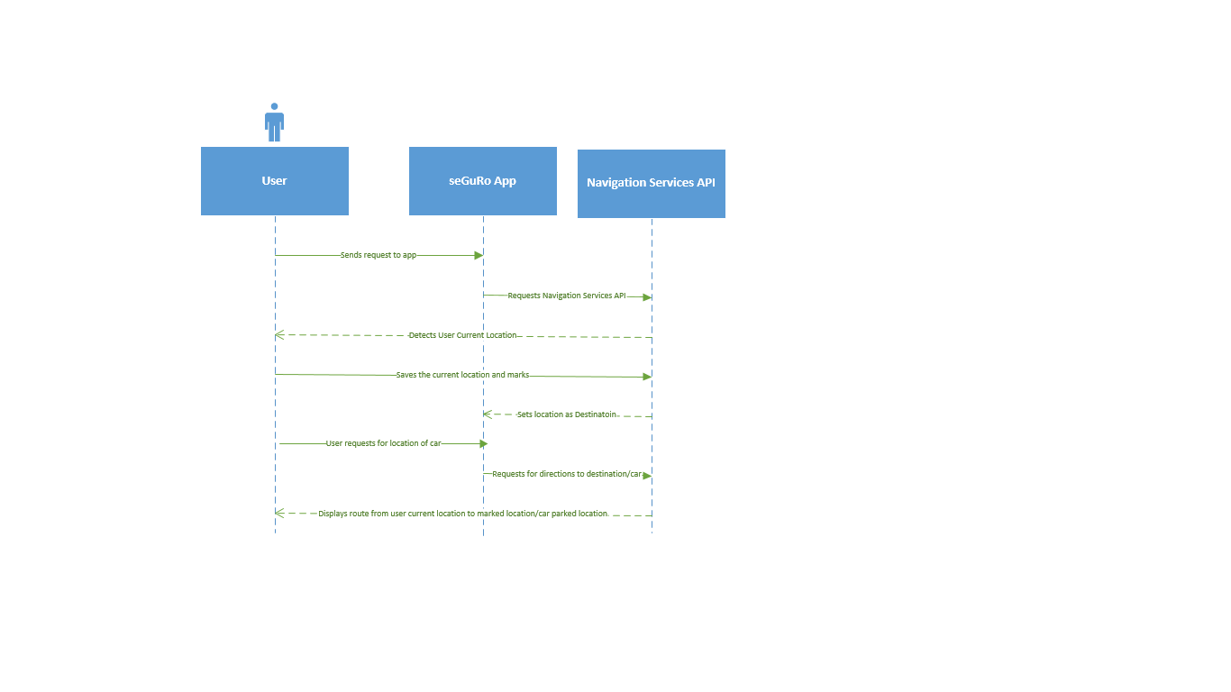

  - Class Diagram

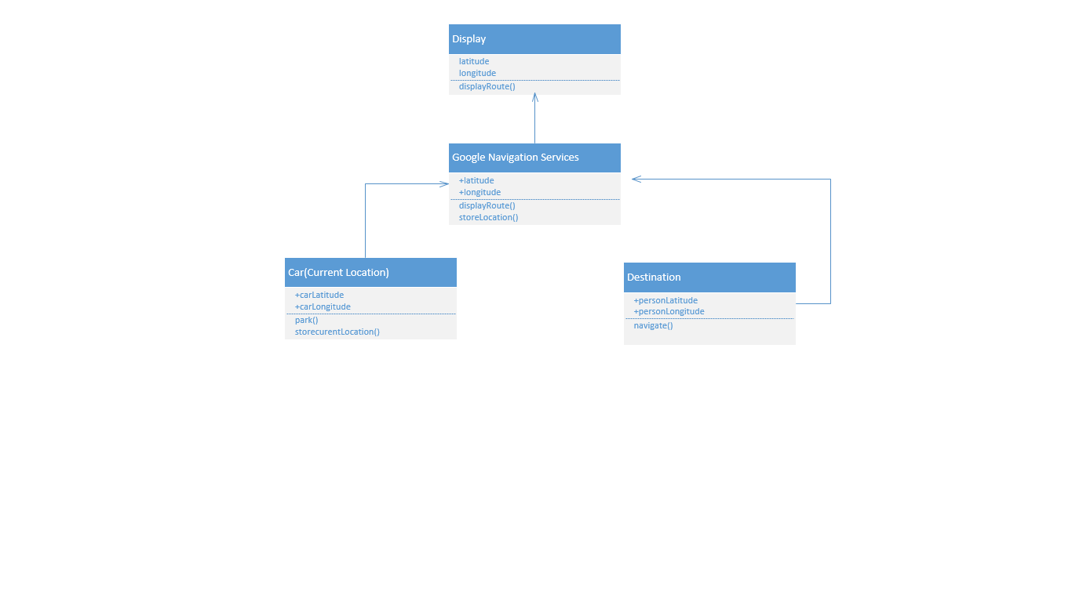

- Implementation
  - Implementation of services
  - Implementation of user interface (Mobile Apps)
  - Implementation of test cases

- Report:

Screen Shot Find My Car App:
The Map displays the navigation from the car parked location to the university.

Registration Page:
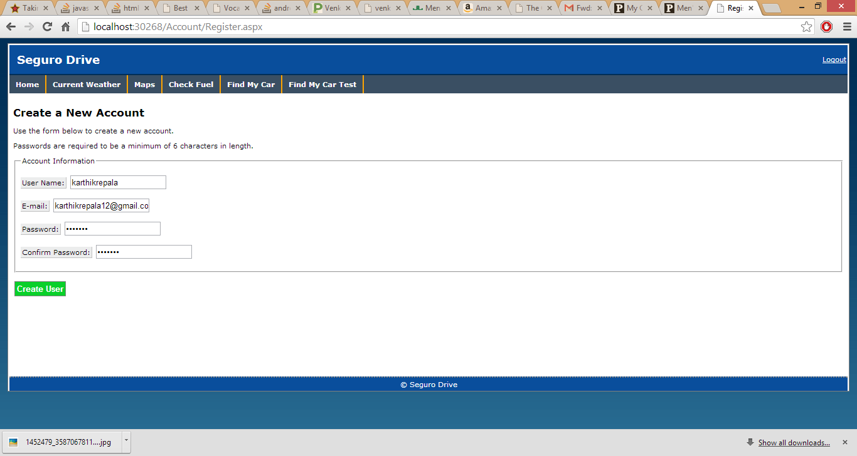
Login Page:
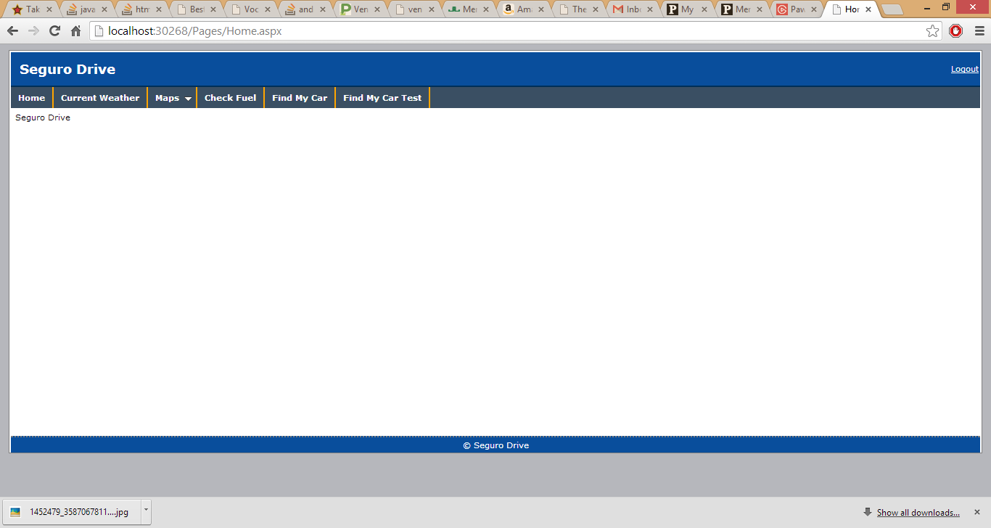

Weather:
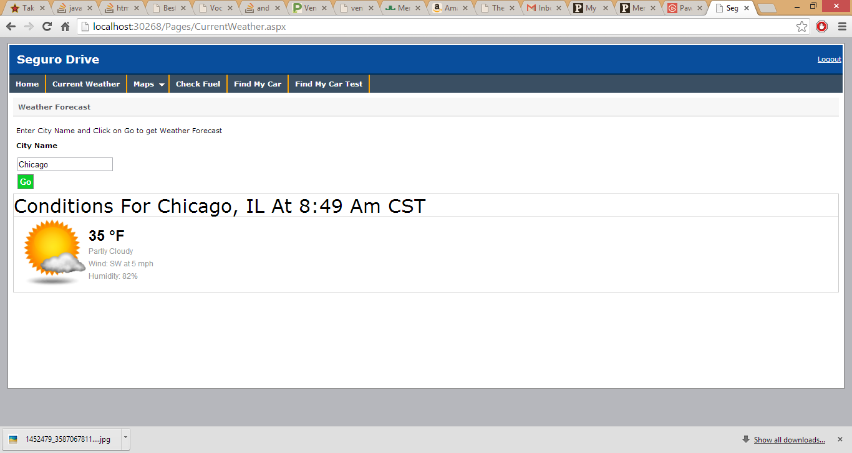

Maps

-Point Map
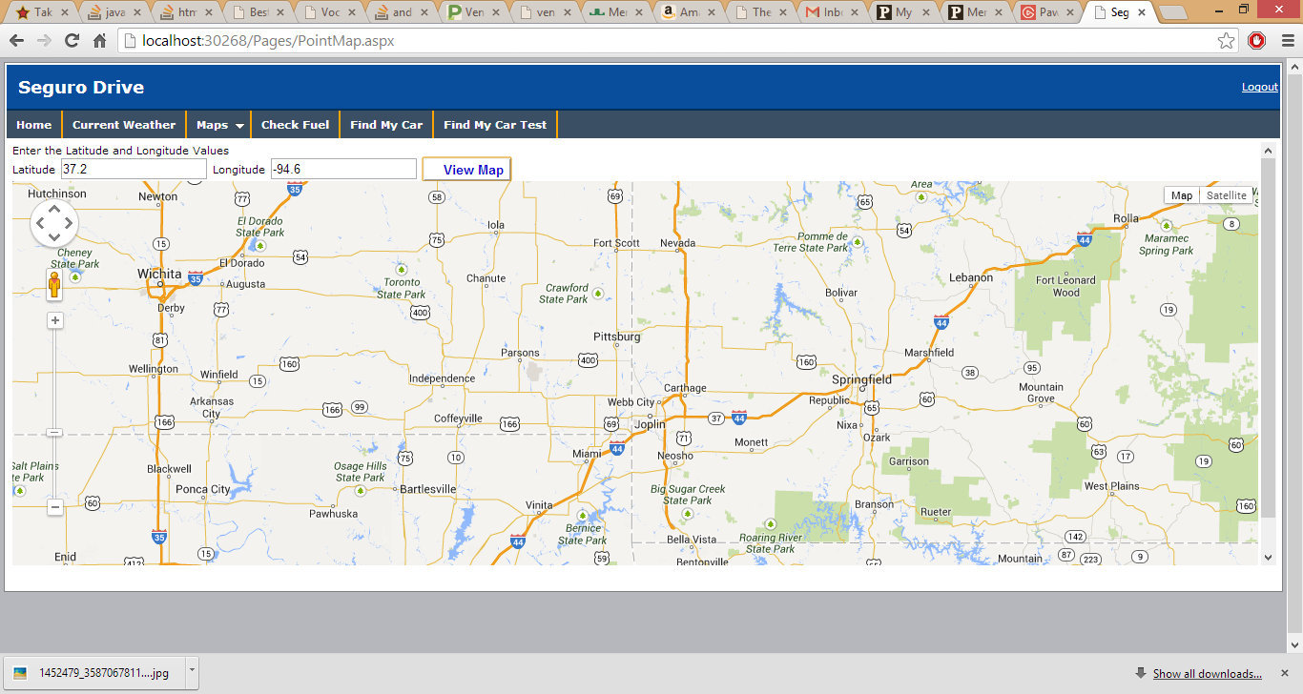

-GeoLocation(Navigation)
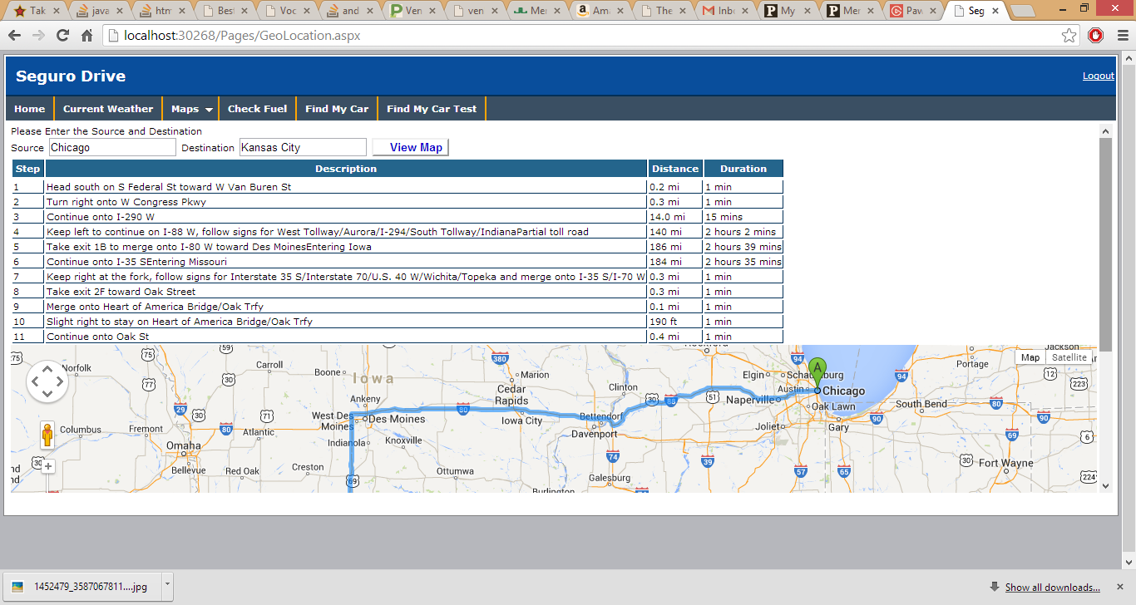

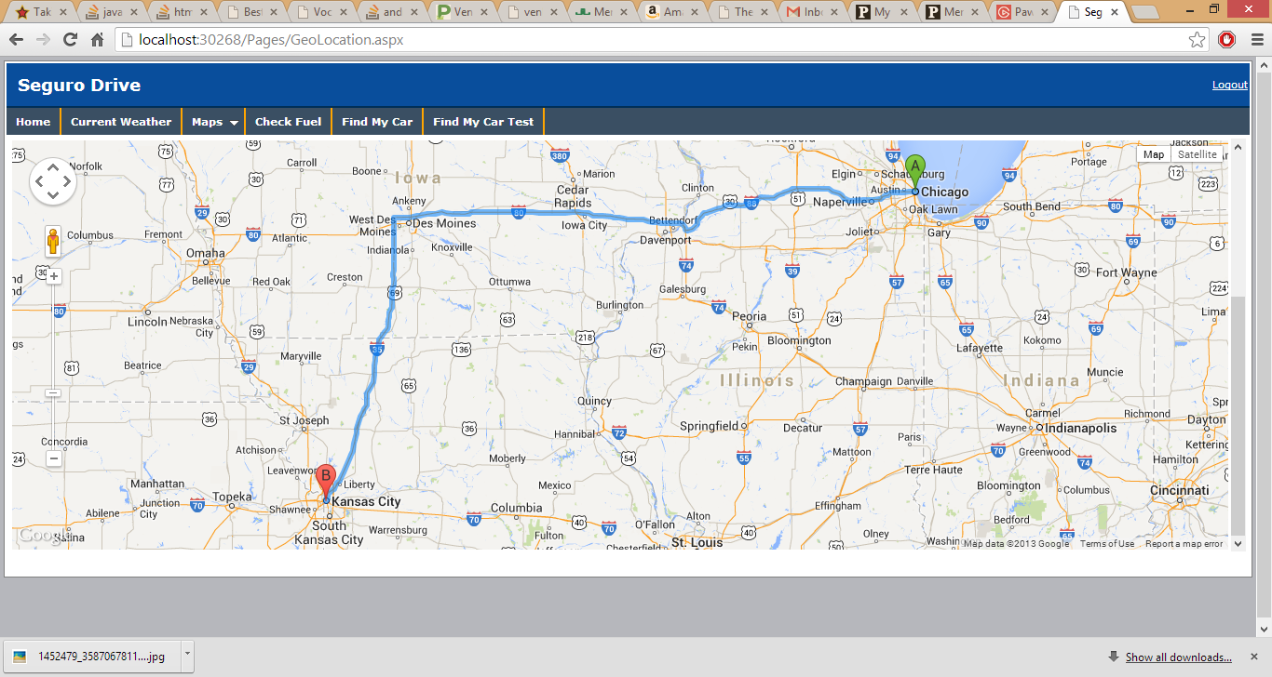

CheckFuel
-Yet to be implemented

Find My Car
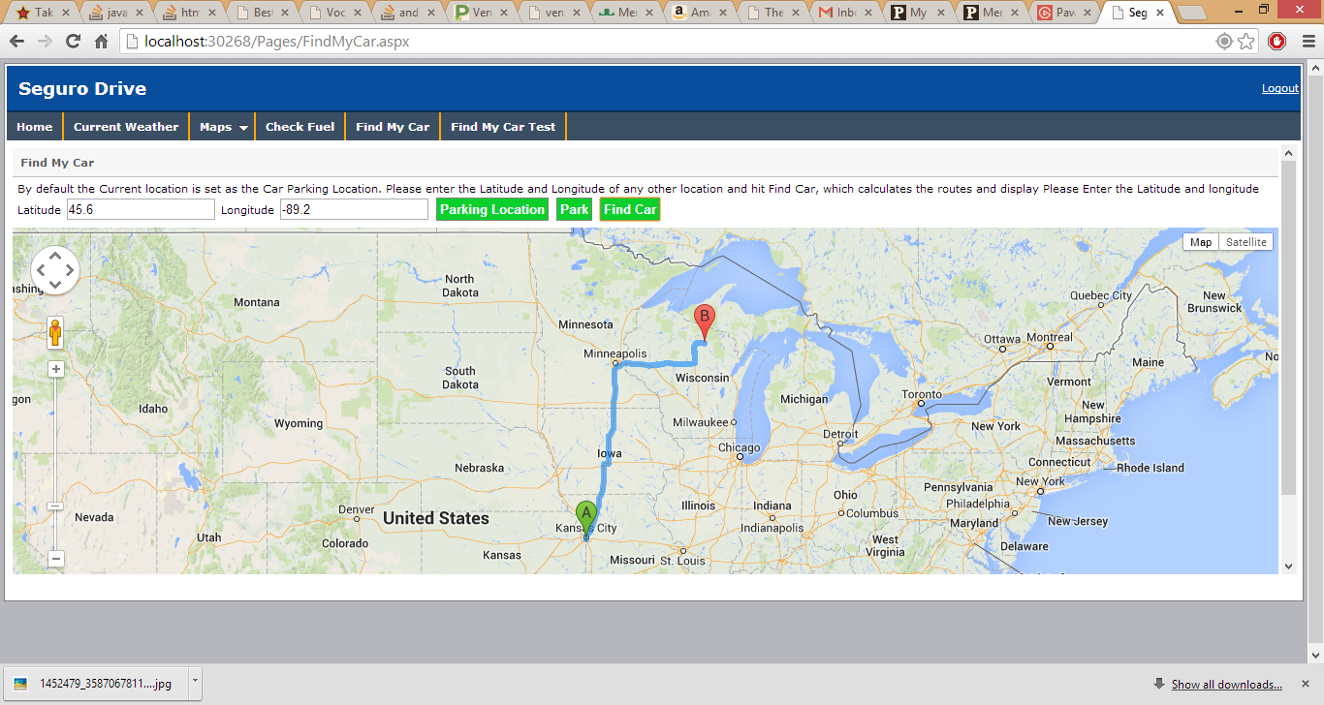

Find My Car Test

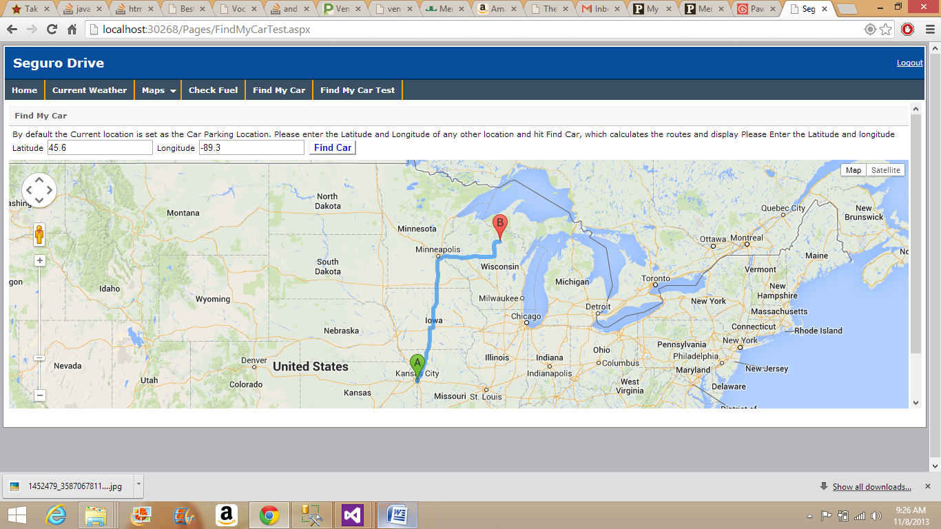

- Project Management:

Story #4 As a team we want to create login and registration pages so that user can log in to the application.
Story #6 As a team we want to change the front end design so that it looks good with application

As part of the third increment login, registration pages are created and changes to the front end design is completed.

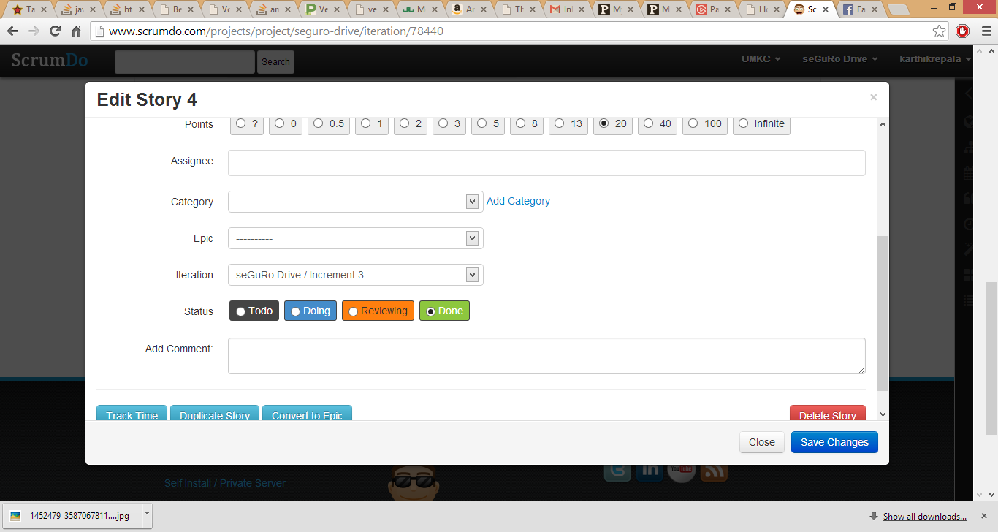

Both the stories have been changed to Completed Phase
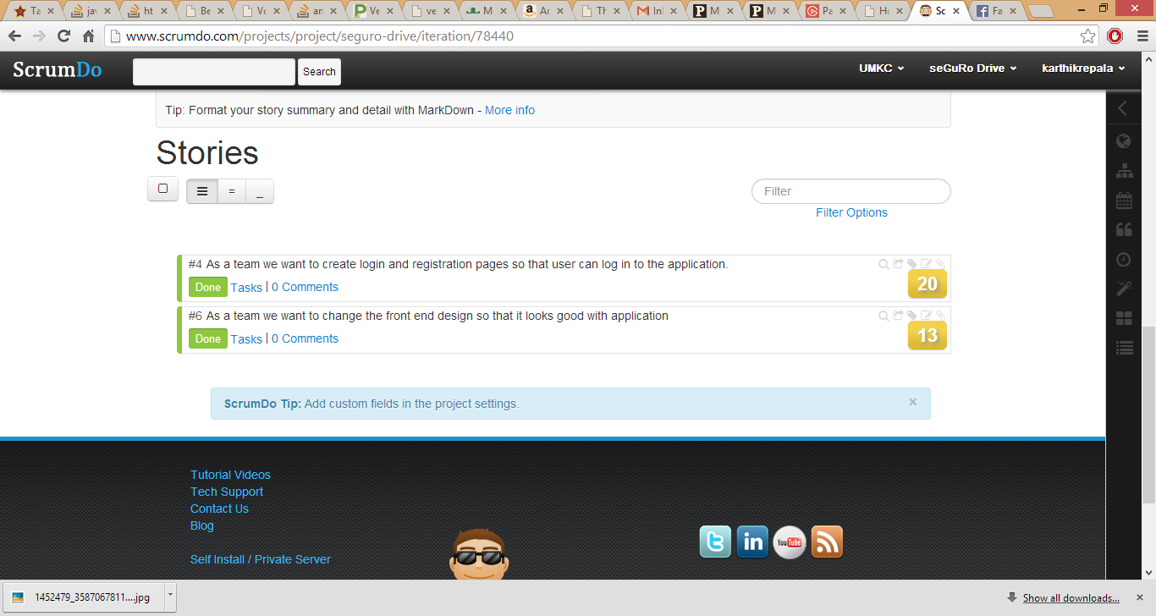

The overview of the seGuRo Drive
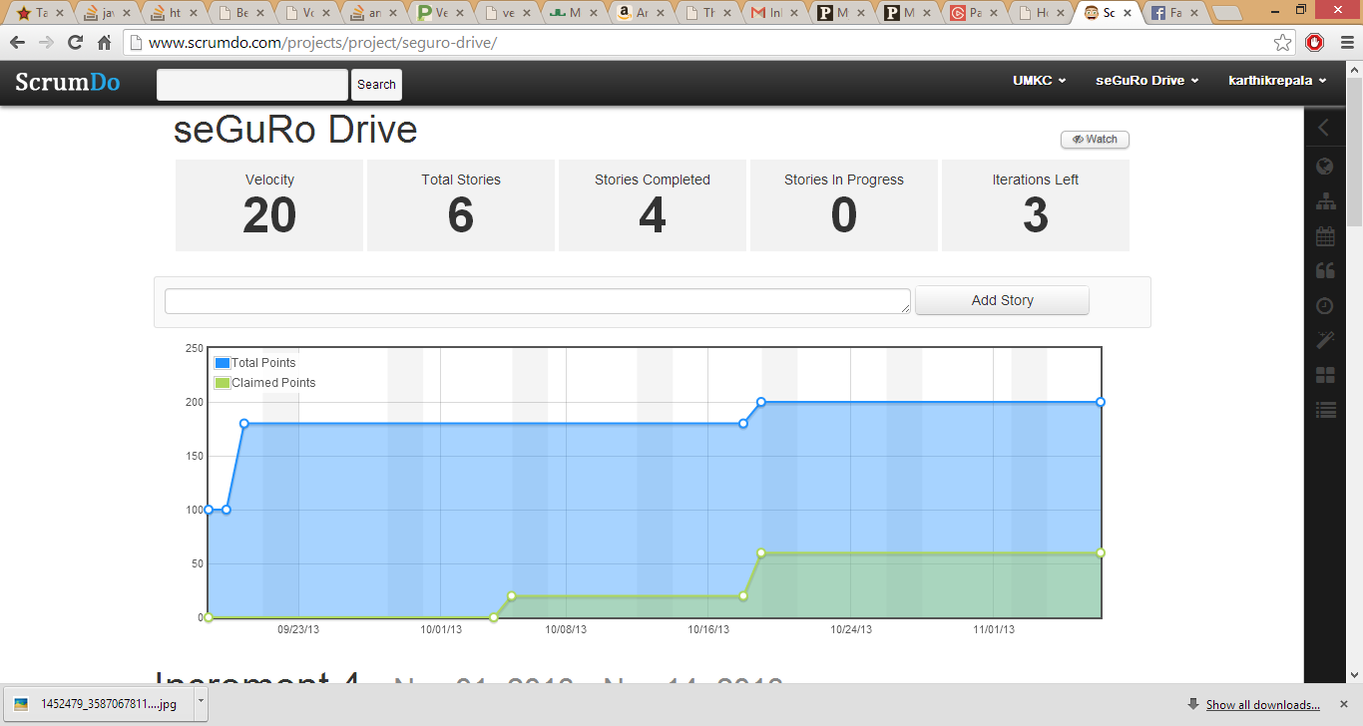

  - Implementation status report

    - Work completed:
      - Find My Car Service
      - Login, Registration and DB.
      - Time taken (40 hours)
      - Responsibility

Shiva - Database, Diagrams, Front End Design
Karthik - DB, Login/Registration, Documentation
Surendra - Updating Find My car, Documentation, Front End Design

    - Work to be completed
      - Fuel Monitoring
      - Responsibility (Share Equally)
      - Time to be taken (50 hours)

    - Issues/Concerns:

- Integration of all modules into cloud.
- Overall Testing needs to be performed.

